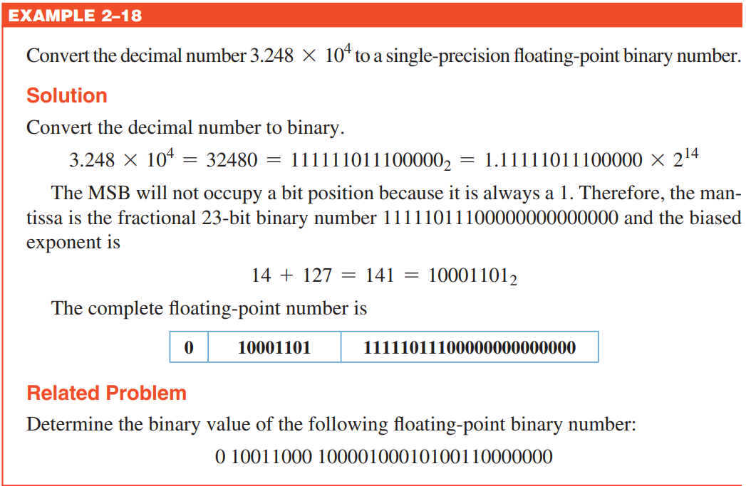

Converting it back into the decimal equivalent form: 1.11111011100000000000000 x 2141

Exponent = 141 – 127 = 14

1.11111011100000000000000 x 214 = (111111011100000)2 = (32480)₁₀

**--Determine the binary value of the following floating-point binary number:   
0 10011000 10000100010100110000000**

Sign Bit indicates the number is positive.

Exponent = 10011000 = 152 – 127 = 25

1.10000100010100110000000 x 225 = (11000010001010011000000000)₂ = (1 × 2²⁵) + (1 × 2²⁴) + (0 × 2²³) + (0 × 2²²) + (0 × 2²¹) + (0 × 2²⁰) + (1 × 2¹⁹) + (0 × 2¹⁸) + (0 × 2¹⁷) + (0 × 2¹⁶) + (1 × 2¹⁵) + (0 × 2¹⁴) + (1 × 2¹³) + (0 × 2¹²) + (0 × 2¹¹) + (1 × 2¹⁰) + (1 × 2⁹) + (0 × 2⁸) + (0 × 2⁷) + (0 × 2⁶) + (0 × 2⁵) + (0 × 2⁴) + (0 × 2³) + (0 × 2²) + (0 × 2¹) + (0 × 2⁰) = (50898432)₁₀

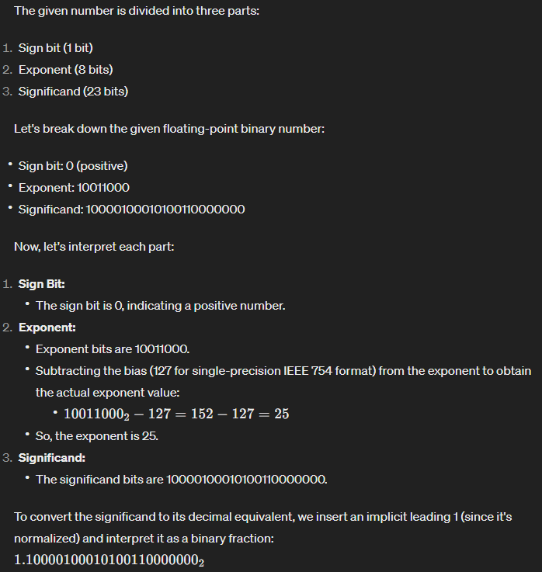  
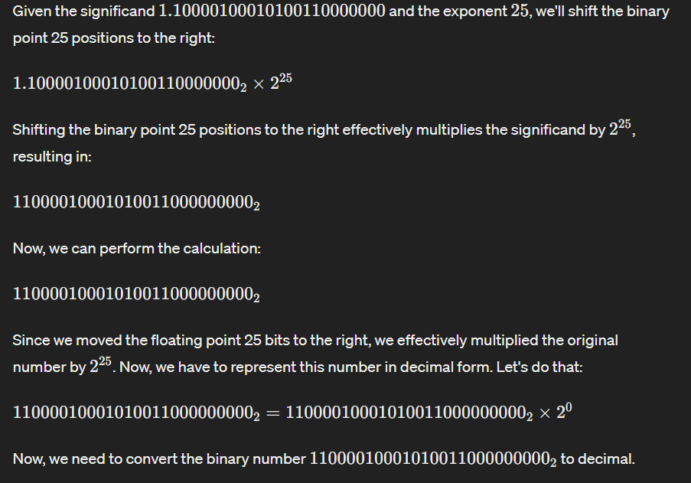

(11000010001010011000000000)2 = 29 + 210 + 213 + 215 + 219 + 224 + 225 = (50898432)10

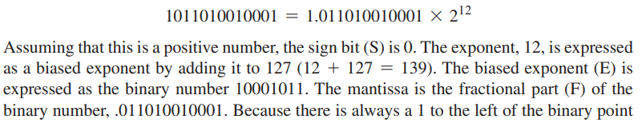

**-----------------THE END-----------------**

General Knowledge👇

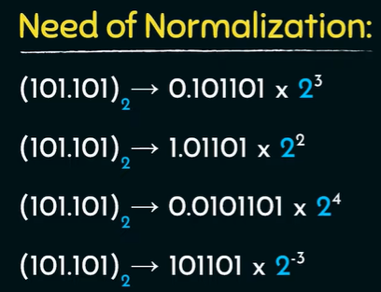

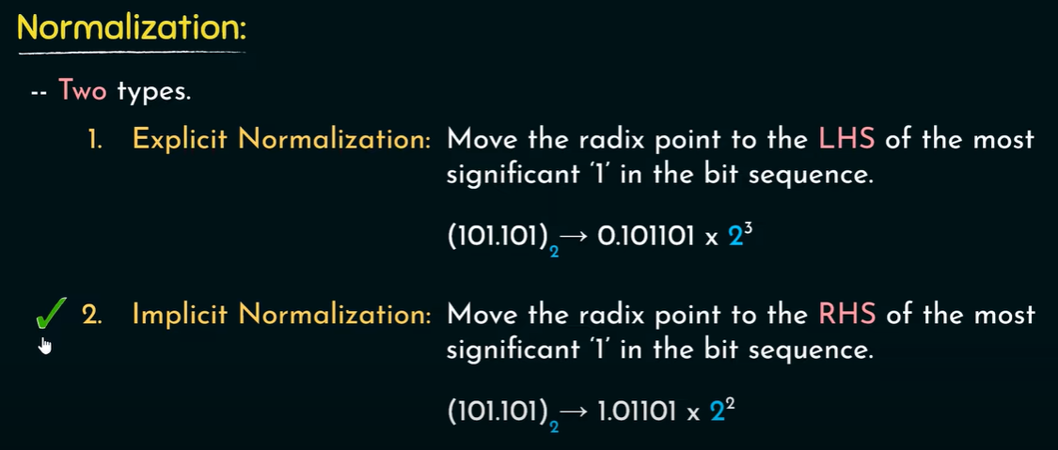

Implicit normalization is better with respect to precision.

Since comparators cannot handle signed and unsigned numbers both, basically they only with unsigned numbers.

We converted the range into an unsigned form.

**Biasing in 10-bit memory space**

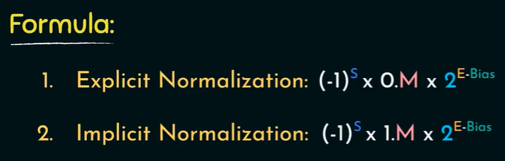

Perform explicit normalization on the first value and implicit normalization on the second value.

This is how the first value (0.0101)2 is going to be saved in the memory using explicit normalization.

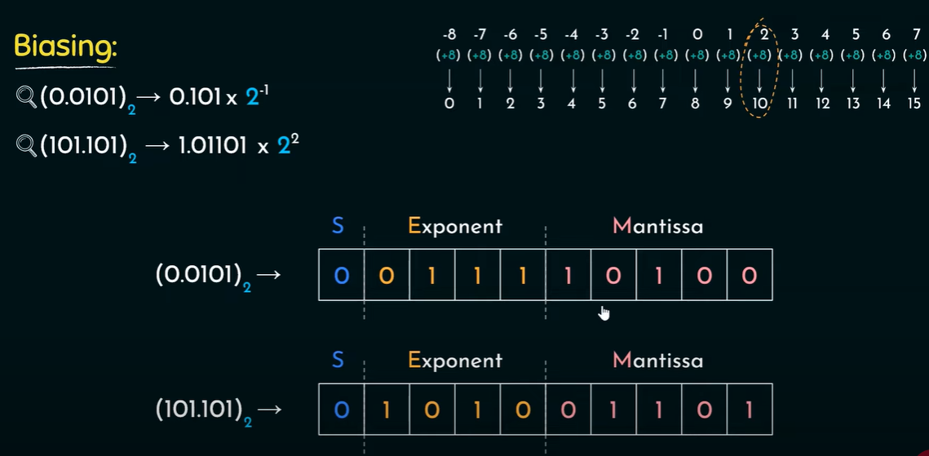

This is how the second value (101.101)2 is going to be saved in the 10-bit memory using implicit normalization.